Time Series Midterm 2020

In-Class Portion **Solution**

**Use the data below for questions 1 – 7.**

The following data are annual sales (in units sold) for a make-believe company:

|  |  |
| --- | --- |
| Time | Units |
| 1 | 10 |
| 2 | 15 |
| 3 | 20 |
| 4 | 19 |
| 5 | 14 |

“By hand” simply means show your work. You may actually write it and take a pick or you may type it.

|  |  |  |  |  |  |  |
| --- | --- | --- | --- | --- | --- | --- |
| Time ( | Value |  |  |  |  | ) |
|  | 10 | 14 | -5.6 | -1.6 | 31.36 | 8.96 |
|  | 15 | - | -0.6 | - | 0.36 | - |
|  | 20 | - | 4.4 | - | 19.36 | - |
|  | 19 | - | 3.4 | - | 11.56 | - |
|  | 14 | - | -1.6 | - | 2.56 | - |
|  |  |  |  |  |  |  |
| **SUM** | 78 |  |  |  | 65.2 | 8.96 |
| **COUNT** | N = 5 |  |  |  | = N = 5 | = N (not N-4) = 5 |
| **AVERAGE** |  |  |  |  |  |  |

1. (5pts) Compute by hand.

**Based on the calculations in the table above, we get**

**Note: QUESTION NUMBER 1 COULD HAVE BEEN SOLVED MANY WAYS…. SOME STUDENTS DID IT WITH PEN AND PENCIL AND TOOK A PICTURE WHILE OTHERS JUST TYPED IT OUT.**

1. (5pts) Compute by hand.

**Based on the calculations in the table above, we get**

1. (5 pts) Compute by hand.

**Based on the calculations in (1) and (2), we get**

Consider the Model and the calculations below (Questions 4 – 7):

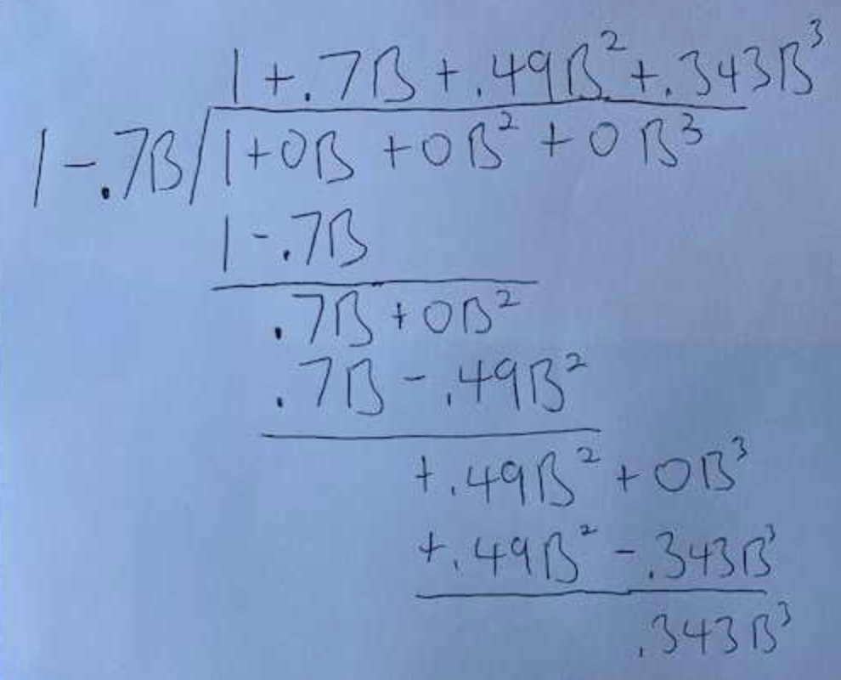***.***

***These are the residual from the fit of the model:***

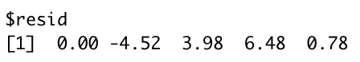

1. (5 pts) Compute (2) by hand.

In this case, and

Substituting the value of from (2) back to (1), we get

1. (10 pts) Compute a 95% prediction interval for (2) by hand. “By hand” means show your calculation of the margin of error as we did in live session. This includes the calculation of the estimate of the white noise variance, . If you are having trouble estimating that parameter, simply use 4 for that value for just a few points off.

Here, = 5, p = 1 and are the residuals that are given in the questions. Hence,

MOE =  **where = 1.96 for 95% confidence intervals**

**Hence,**

**The 95% prediction interval** =

1. (5pts) Write this AR(1) model as a GLP (just the first 3 terms).
2. (5pts) Is this model stationary? Is it invertible?

**Since which is < 1, this model is stationary. This can be considered as an ARMA model with . Since the root of the MA side will approach infinity (which is outside the unit circle), this model is invertible.**

1. Matching: Match the letter to the number below the labeled ACFs and realizations. (2pts each )

|  |  |
| --- | --- |
| 1. | A. |
| 2. | B. |
| 3. | C. |
| 4. | D. |
| 5. | E. |

1. D 2. E 3. C 4. A 5. B
2. Matching: Match the letter to the number below of the acf or realization to the Spectral Density. (2pts each)

|  |  |
| --- | --- |
|  |  |
|  |  |
|  |  |
|  |  |
|  |  |

1. B 2. A 3. D 4. E 5. C
2. (3 pts) Estimate the dominant period that is associated with this spectral density. It just needs to be close… not exact.

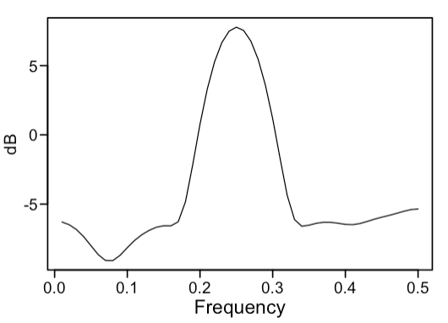

Answer: Dominant Frequency = 0.25 🡪 Dominant Period = 1/0.25 = **4**

1. (2 pts) Which is the higher pass filter?
2. 10 point Moving Average
3. **Difference**
4. Not Enough Information

**Answer B**

1. (2pts) Assume our data has passed through a high pass filter. Which spectral density is most associated with the resulting series (after the high pass filter)?
2. 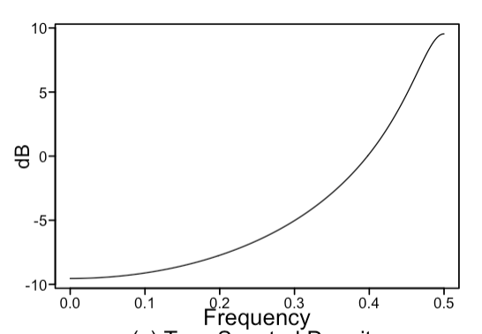 b. 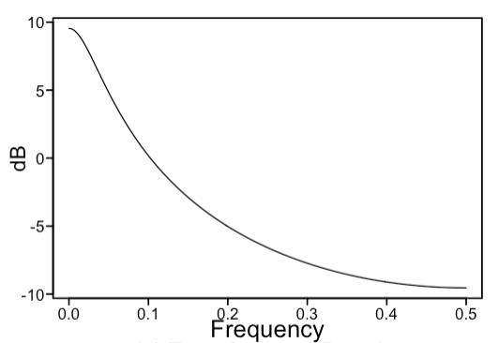

**Answer: a**

1. (3 pts) Identify/specify a model that will forecast the trend and the seasonality to continue indefinitely. Models will vary. Write it in factored form in backshift notation.

**Answer: The airline model will forecast the trend and seasonality indefinitely.**

Consider the following factor table for questions 14 - 16:

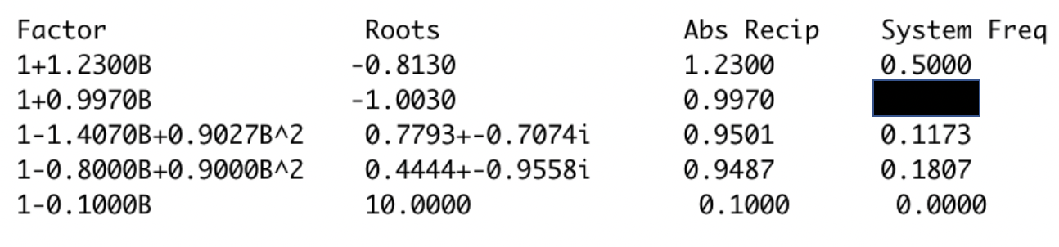

1. (3pts) Is this a factor table of model that generates a stationary or non-stationary time series? Why? (One sentence is fine.)

**Answer: This is a non-stationary model since the Abs. Reciprocal of the root associated with the system frequency of 0.5 is > 1**

1. (3 pts) What is the value of the blacked-out system frequency?

**Answer: Since is negative, this root is associated with a system frequency of 0.5**

1. (2pts) Which factor will have the least dominance if a realization was generated from this model? What type of behavior is that factor associated with?

**Answer: The least dominant factor is the one with an Abs Reciprocal of 0.1 since it is further away from the unit circle compared to the other roots. Since this is associated with a positive real , this will be associated with wandering behavior.**

1. (2 pts) True / **False**. All invertible models are stationary.

**We may have AR models which are invertible but not stationary**

1. (3 pts) The model with the lowest AIC is the correct / right model.

**Answer: False. The model with the lowest AIC is just one model to consider for the data at hand. There may be other metrics that we may wish to use to pick the best fit model. Also, if the lowest AIC model does not align well with our domain knowledge of the dataset, it may be reasonable to pick another model which may not have the lowest AIC.**

1. (2pts) What is George Box’s famous quote that we use in class all the time?

**“All models are wrong, but some are more useful than others”**

1. (2 pts) Consider a realization generated by model described in the following code. **gen.sigplusnoise.wge(100, b0 = 0, b1 = .5, phi = .95, vara = 8)**

Would this realization come from a stationary or non-stationary process?

**Answer: This would come from a non-stationary process, since the mean is a (linear) function of time with AR(1) noise superimposed on top. This signal does not meet the first requirement for stationarity that subpopulations of have the same mean for each ‘t’, i.e. the mean does not depend on time.**

**However, we must be careful when looking at the realizations alone. In this case the white noise variance is quite high so we may just get a realization in which the linear trend is not so prominent which may lead us to think it is stationary (when the underlying process generating it is nonstationary).**

1. (1 pt each) Identify the following models identifying it as AR, MA, ARMA, ARIMA or White Noise and identifying the p,d,q and s as is appropriate.
2. (1-.8B+ .7B2(1-B)(1-B6)Xt=(1-.8B)(1+.7B-.9B2)at

**ARIMA model with p = 2, d = 1, q = 3, and s = 6**

1. (1-.9B)Xt = at

**AR(1) model with p = 1**

1. (1+.7B)Xt = (1+.7B)at

**White noise since the AR factor cancels out the MA factor**

1. Match the models with their corresponding acfs, realizations or spectral densities (2pts each)

|  |  |
| --- | --- |
| 1. AR(1) negative phi |  |
| 1. Airline model |  |
| 1. AR(2) |  |
| 1. ARMA(2,2) |  |
| 1. ARIMA(0,0,0) s = 4 |  |

1. B 2. E 3. C 4. D 5. A